 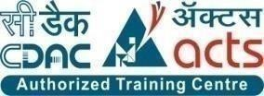

**INSTITUTE FOR ADVANCED COMPUTING ANDSOFTWARE DEVELOPMENT (IACSD), AKURDI, PUNE**

Documentation On

**ROYALSHELL RESORT SYSTEM**

PG-DAC March 2023

# Submitted By:

**Group No: 24**

**Roll No. Name:**

**233041 Ms. Janhavi Shinde**

**233081 Mr. Sachin Sangde**

# Mrs.Megha Mane Mr. Rohit Puranik

**Project Guide Centre Coordinator**

# ABSTRACT

The project, Royalshell Resort System is a web based application that allows the resort Admin to handle resort activities online. Project provides room booking and other necessary resort management features. The system allows the Admin to manage rooms, services, categories in the system. Customers can view available rooms and book room online. Other hotel services can also be viewed by the customers.

Royalshell Resort System aimed at streamlining and enhancing various operations within a resort setting. This system integrates modern technology to efficiently manage reservations, guest services, facilities, and staff coordination. It encompasses a user-friendly interface for guests to make reservations, view amenities, and access information. Additionally, the system enables staff to manage room assignments, housekeeping, and maintenance tasks seamlessly. By leveraging data analytics, the system aids in decision-making, optimizing resource allocation, and improving customer experiences. Overall, the Resort Management System offers an innovative solution to elevate operational efficiency, guest satisfaction, and overall profitability within the resort industry.

# ACKNOWLEDGEMENT

I take this occasion to thank God, almighty for blessing us with his grace and taking our endeavor to a successful culmination. I extend my sincere and heartfelt thanks to our esteemed guide, **Mrs.Megha Mane** for providing me with the right guidance and advice at the crucial juncture sand for showing me the right way. I extend my sincere thanks to our respected **Centre Co-Ordinator Mr.Rohit Puranik**, for allowing us to use the facilities available. I would like to thank the other faculty members also, at this occasion. Last but not the least, I would like to thank my friends and family for the support and encouragement they have given me during the course of our work.

#### Janhavi Shinde (233041)

**Sachin sangde (233081)**

# Index

|  |  |
| --- | --- |
| **Section** | **Table Title** |
| 1 | List of table |
| 2 | List of figure |
| 3 | Introduction |
| 4 | Activity diagram |
| 5 | System analysis |
| 6 | System design |
| 7 | Diagram |
| 8 | Table Screenshot |
| 9 | Project UI Screenshot |
| 10 | Conclusion |
| 11 | References |

### **LIST OF TABLES**

|  |  |
| --- | --- |
| **Section** | **Table Title** |
| 1 | User |
| 2 | Booking |
| 3 | Rooms |
| 4 | Facility |
| 5 | Room Category |
| 6 | Room Facility |
| 7 | Enquiry |
| 8 | Idproof |
| 9 | Offers |

**LIST OF FIGURES**

|  |  |
| --- | --- |
| **Section** | **Figure Title** |
|  | Admin Activity Diagram |
|  | Customer activity Diagram |
|  | 0 level DFD |
|  | 1 level DFD |
|  | ER Diagram |
|  | Class Diagram |
|  | Home Page |
|  | Sign up |
|  | Sign in |
|  | Book room |
|  | Rooms |
|  | Facility |
|  | Offers |
|  | My Booking |
|  | Available Rooms |
|  | Contact Us |
|  | Enquiry |
|  | Admin Home |
|  | Add Room |
|  | Room List |
|  | User List |
|  | Booking List |
|  | Add Idproof |
|  | Idproof List |
|  | Add Room Category |
|  | Room Category List |
|  | Add Facility |
|  | Facility List |
|  | Enquiry List |
|  | Add Offers |
|  | Offers List |
|  | Search By User Id |
|  | Search By Booking Id |
|  | Search By Dates |
|  | Edit Contact Us |

### **INTRODUCTION**

Now a days peoples are want to go different places for relaxation or recreation. As, there are not so many available hotels & Resorts for large number of peoples. In a vacation, most of the peoples will go different tourist places for relaxation or recreation and have to be faced embracing situation if there is not available room in Hotel & Resort. It will be overcome if the Resort has online booking system.

For this reason, we think that if the Resort Booking and availability checking system, we can provide the customers through Online, then it will be more convenient and helpful for a customer perspective to Book/Reserve a Room or checking the price, availability and other facilities.

Moreover, like “**RoyalShell Resort System**” can also help the Peoples who are basically like to confirm the booking before the traveling to minimize the hassle during the traveling. Moreover, Management also gets a view about the Daily/Monthly income from tourist and also able to compare with the costing to find out the Net Income.

**Project Objectives:**

* Develop a user-friendly software interface for hotel staff.
* Improve guest experience through efficient check-in/out procedures.
* Automate room allocation and reservation management.

**Project Overview:**

The Royalshell Resort System is a comprehensive solution designed to streamline and enhance the operations of a resort. It encompasses various modules for efficient reservation management, guest services, and staff coordination. The system provides guests with a user-friendly platform to make reservations, explore resort amenities, and access relevant information. For staff, it facilitates tasks such as room assignment, housekeeping, and maintenance through an integrated interface. Leveraging data analytics, the system aids in decision-making, optimizing resource allocation, and improving guest experiences.

**Scope:**

* The project RoyalShell Resort Management System is a web-based application that allows the resort Admin to handle all resort activities online.
* Project provides room booking and other necessary resort management features.
* The system allows the admin to post available rooms, facility, offers in the system.
* Customers can view and book room online. Customers can send Enquiry.
* Other hotel services and offers can also be viewed by the customers.

Activity Diagrams:

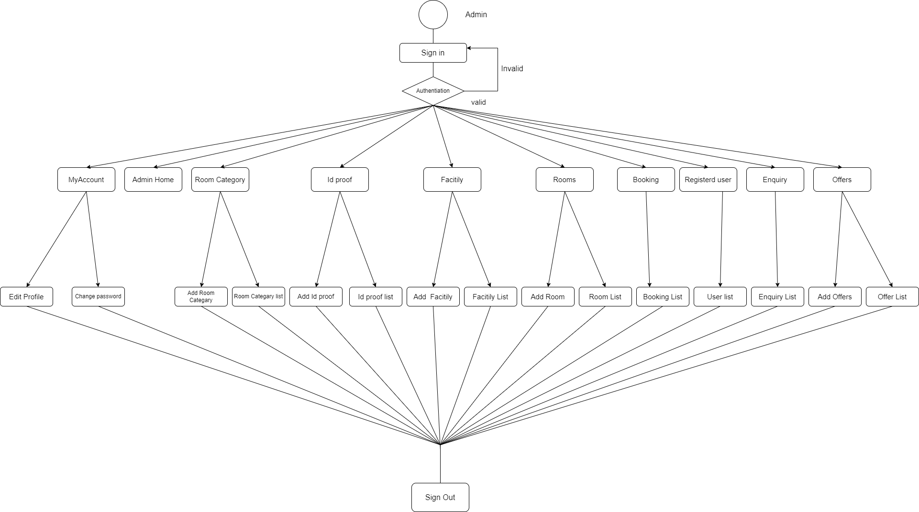

### Figure 1 Admin Activity Diagram

**1) My Account**

Edit profile-admin can add his/her personal data .

**2)Id-proof**

Admin can provide option for Id proof of customer.

**3)Facility**

Admin can provide facility for each category of the room

**4)Booking**

Admin can able to see booking of the room which is done by register customer .

**5)Register User**

Only Admin can see register user list and remove option also their.

**6)Change password**

admin can change password but with same email ID.

**7)Enquiry**

Customer enquiry list approved by the admin in this section

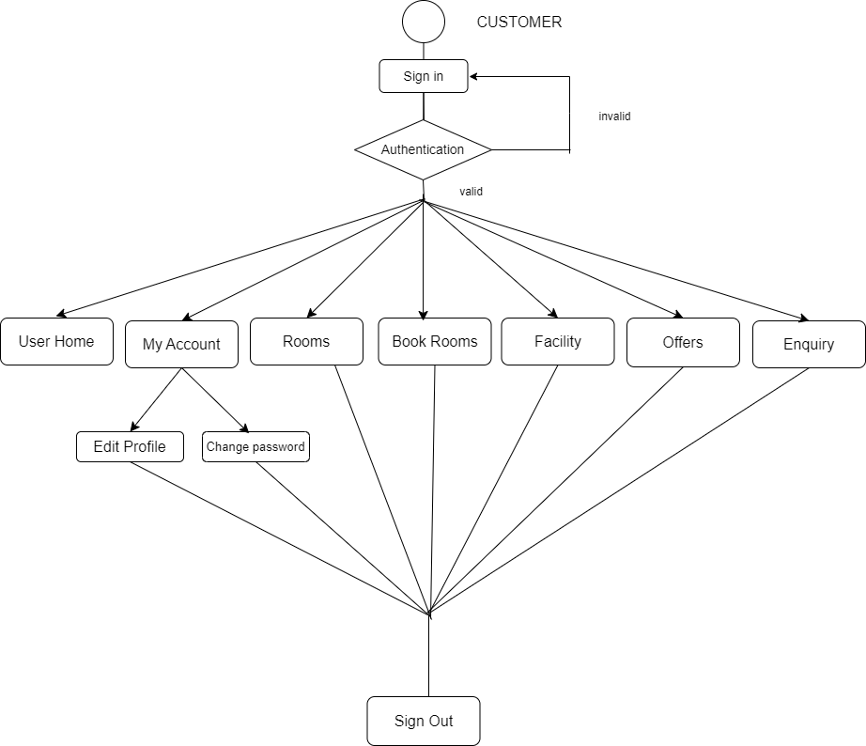

### Figure 2 Customer Activity Diagram

**1) My Account**

User can add his/her personal data and change password also

**2)Booking Rooms**

By selecting date user can able to select and chose appropriate rooms.

**3)Facility**

User can see each category of the room like double , queen etc

**4)Offers**

User can able to see offer which is provided by resort.

**5)Enquiry**

Register user can able to do enquiry against various aspect like availability, refund etc

# SYSTEM ANALYSIS

System analysis is the process of gathering and interpreting facts, diagnosing problems, and using the information to recommend improvements on the system. System analysis is a problem-solving activity that requires intensive communication between the system users and system developers.

System analysis or study is an important phase of any system development process. The system is viewed as a whole, the inputs are identified, and the system is subjected to close study to identify the problem areas. The solutions are given as a proposal. The proposal is reviewed on user request and suitable changes are made. This loop ends as soon as the user is satisfied with the proposal.

## EXISTING SYSTEM

The current system for resort system is maintain pen and paper data to add new customer of the rooms. To inform customer manager publish ads in news paper , television and pamphlet which is quite tadious.

* + - It is less user-friendly.
    - It is a time-consuming process to book room on counter
    - Maintain register for each entry or check in
    - Condition of the place and amenities of hotel is not known

## PROPOSED SYSTEM

* + - **Accessibility:** Staff can manage operations remotely, ensuring efficient service delivery regardless of location.
    - **Real-time Updates**: Instant data synchronization prevents communication gaps and keeps all departments informed.
    - **Streamlined Operations**: Automation of tasks like reservations and billing minimizes errors and boosts efficiency.
    - **Centralized Information:** All departments access a single database, improving coordination and guest experiences.

## SYSTEM REQUIREMENT SPECIFICATION

**Requirements-**

a) Functional Requirements-

i) User Registration and Login

• Users can create accounts and log in securely.

• User profiles store personal information.

ii) Resort Search and Filtering

• Users can search for resorts based on location, date, and other criteria.

• Results can be filtered and sorted

iii) Resort Details and Images

• Users can view detailed information about a selected resort.

• High-quality images showcase the resort's amenities.

iv) Room Availability Check

• Users can check room availability for specific dates.

• Real-time availability status is displayed.

v) Online Booking and Payment

• Users can select available rooms and make bookings.

• Payment processing is secure and seamless.

b) Non-Functional Requirements-

i) Performance

• The system should handle concurrent user interactions without significant slowdowns.

• Page load times should be optimized.

ii) Security

• User passwords should be securely hashed and stored.

• Payment information must be encrypted during processing.

iii) Usability

• The UI should be intuitive and user-friendly.

• Error messages should be clear and informative.

iv) Reliability

• The system should be available 24/7 with minimal downtime for maintenance.

# SYSTEM DESIGN

System design is the solution for the creation of a new system. This phase focuses on the detailed implementation of the feasible system. Its emphasis on translating design. Specifications to performance specification. System design has two phases of development.

* Logical Design
* Physical Design

During logical design phase the analyst describes inputs (sources), outputs(destinations), databases (data sores) and procedures (data flows) all in a format that meets the user requirements. The analyst also specifies the needs of the user at a level that virtually determines the information flow in and out of the system and the data resources. Here the logical design is done through data flow diagrams and database design. The physical design is followed by physical design or coding. Physical design produces the working system by defining the design specifications, which specify exactly what the candidate system must do. The programmers write the necessary programs that accept input from the user, perform necessary processing on accepted data and produce the required report on a hard copy or display it on the screen.

## INPUT AND OUTPUT DESIGN

#### INPUT DESIGN:

Input design is the link that ties the information system into the world of its users. The input design involves determining the inputs, validating the data, minimizing the data entry and provides a multi-user facility. Inaccurate inputs are the most common cause of errors in data processing. Errors entered by the data entry operators can be controlled by input design. The user-originated inputs are converted to a computer-based format in the input design. Input data are collected and organized into groups of similar data. Once identified, the appropriate input media are selected for processing. All the input data are validated and if any data violates any conditions, the user is warned by a message. If the data satisfies all the conditions, it is transferred to the appropriate tables in the database. In this project the student details are to be entered at the time of registration. A page is designed for this purpose which is user friendly and easy to use. The design is done such that users get appropriate messages when exceptions occur.

#### 

#### OUTPUT DESIGN:

Computer output is the most important and direct source of information to the user. Output design is a very important phase since the output needs to be in an efficient manner. Efficient and intelligible output design improves the system relationship with the user and helps in decision making. Allowing the user to view the sample screen is important because the user is the ultimate judge of the quality of output. The output module of this system is the selected notifications.

# PROJECT DESIGN

**1)DATABASE**

Databases are the storehouses of data used in the software systems. The data is stored in tables inside the database. Several tables are created for the manipulation of the data for the system. Two essential settings for a database are

* Primary key - the field that is unique for all the record occurrences
* Foreign key - the field used to set relation between tables Normalization is a technique to avoid redundancy in the tables.

#### MySQL:

MySQL is the world's second most widely used open-source relational database management system (RDBMS). The SQL phrase stands for Structured Query Language.

## 2)SYSTEM TOOLS

The various system tools that have been used in developing both the front end and the back end of the project are being discussed in this chapter.

#### 2.1 FRONT END:

React is a library which is developed by Facebook are utilized to implement the frontend. React (also known as React.js or ReactJS) is a [free and open-source](https://en.wikipedia.org/wiki/Free_and_open-source_software) [front-end](https://en.wikipedia.org/wiki/Free_and_open-source_software) [JavaScript](https://en.wikipedia.org/wiki/JavaScript_library) [library](https://en.wikipedia.org/wiki/JavaScript_library) for building [user interfaces](https://en.wikipedia.org/wiki/User_interfaces) or UI components. It is maintained by [Facebook](https://en.wikipedia.org/wiki/Facebook%2C_Inc) and a community of individual developers and companies. React can be used as a base in the development of [single](https://en.wikipedia.org/wiki/Single-page_application) [page](https://en.wikipedia.org/wiki/Single-page_application) or mobile applications. However, React is only concerned with state management and rendering that state to the [DOM,](https://en.wikipedia.org/wiki/Document_Object_Model) so creating React applications usually requires the use of additional libraries for routing, as well as certain client-side functionality.

#### 2.2 BACKEND:

The back end is implemented using MySQL which is used to design databases.

#### Spring-Boot:

This is used to connect MYSQL and fetch data from database and store the data in database. The Spring Framework is a[n application framework](https://en.wikipedia.org/wiki/Application_framework) and [inversion of control container](https://en.wikipedia.org/wiki/Inversion_of_control) for the [Java](https://en.wikipedia.org/wiki/Java_platform) [platform.](https://en.wikipedia.org/wiki/Java_platform) The framework's core features can be used by any Java application, but there are extensions for building web applications on top of the [Java EE](https://en.wikipedia.org/wiki/Java_EE) (Enterprise Edition) platform. Although the framework does not impose any specific [programming model,](https://en.wikipedia.org/wiki/Programming_model) it has become popular in the Java community as an addition to the [Enterprise JavaBeans](https://en.wikipedia.org/wiki/Enterprise_JavaBeans) (EJB) model. The Spring Framework is Open-source Framework.

# 

# 0 Level DFD

**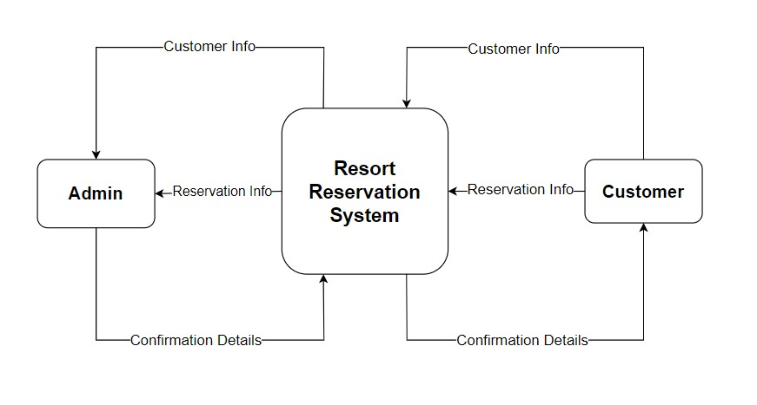**

**Fig1. 0 Level DFD**

# 1Level DFD

**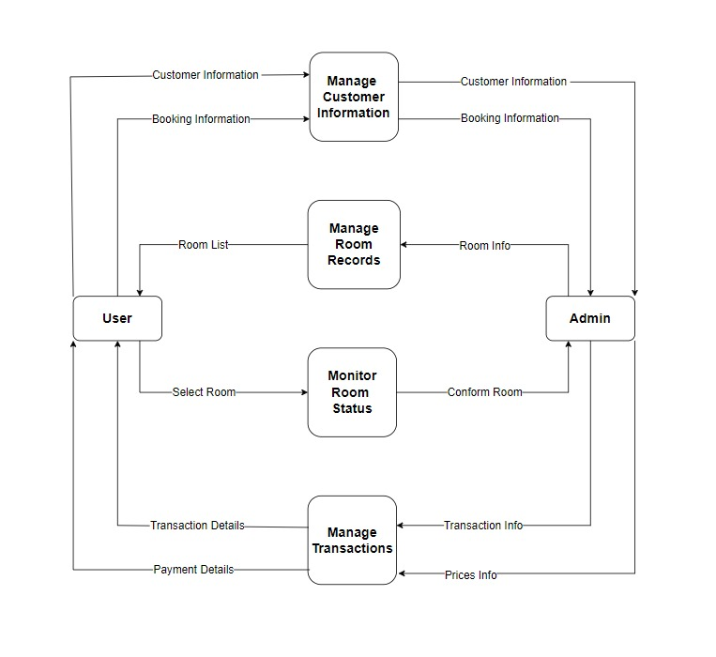**

**Fig2. 1 Level DFD**

# E-R Diagram:

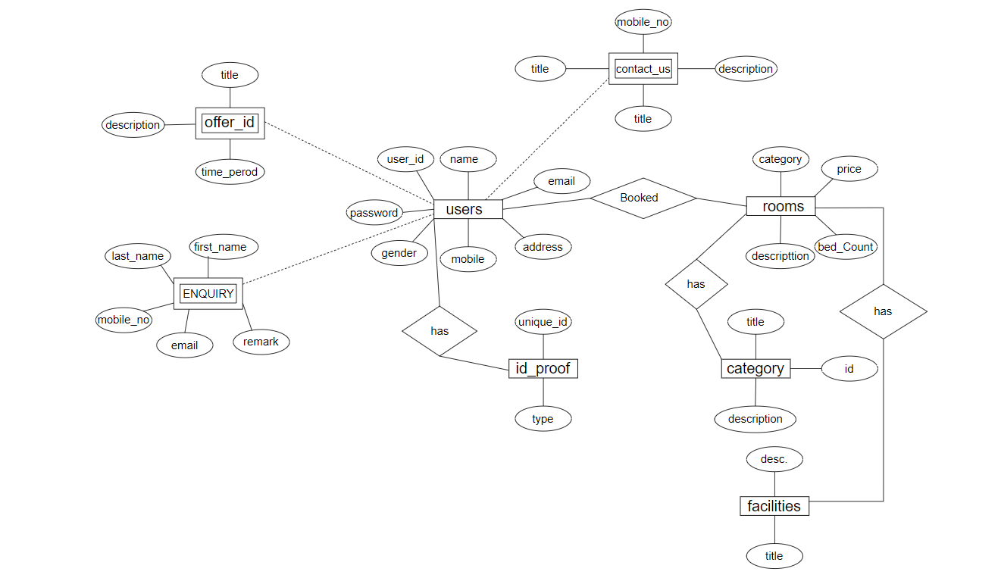

Fig3. ER Diagram

# Class Diagram

# C:\Users\Shree\Desktop\royalshellFinal\cdac project-database\project\diagram\Er_sys.png

# 

# TABLE STRUCTURE

**Booking**

**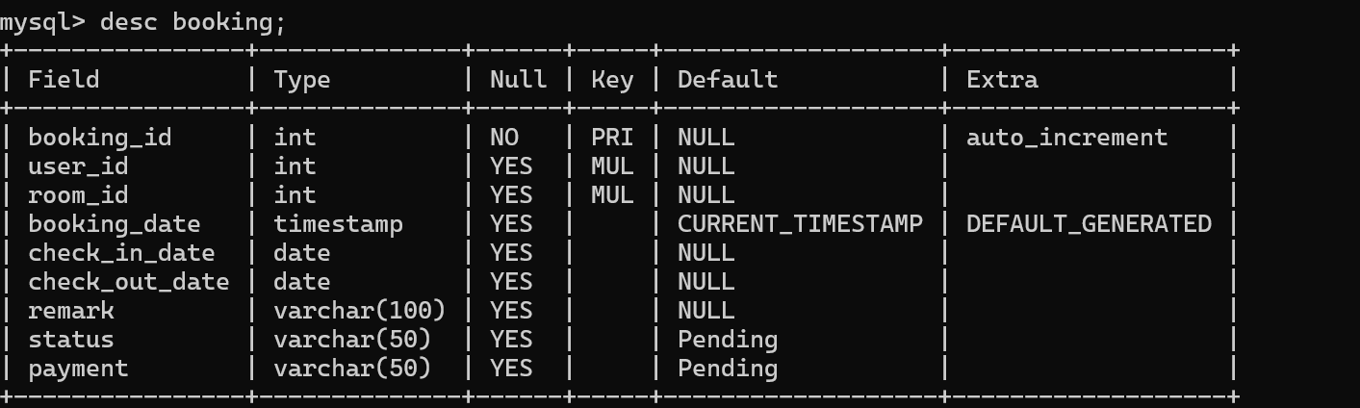**

**Contact\_us**

**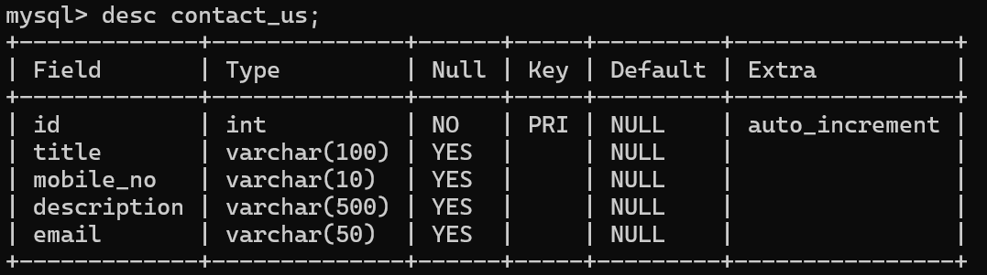**

**Enquiry**

**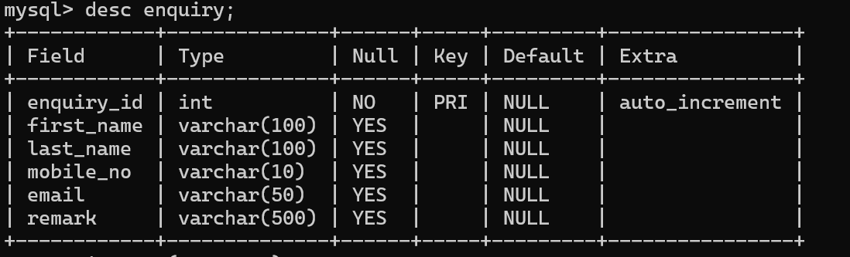**

**Facility**

**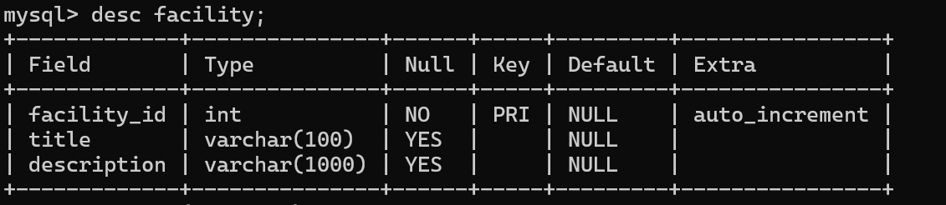**

**Id-proof**

**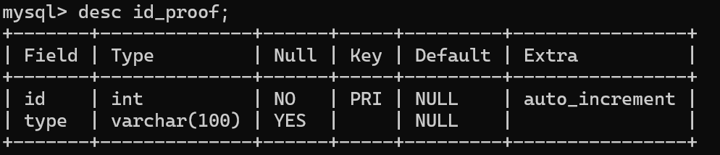**

**Offers**

**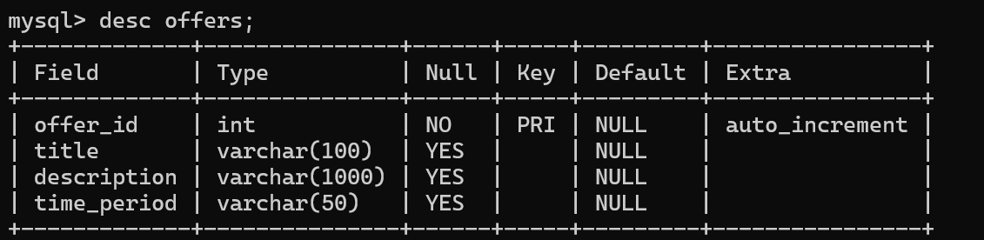**

**Room-Category**

**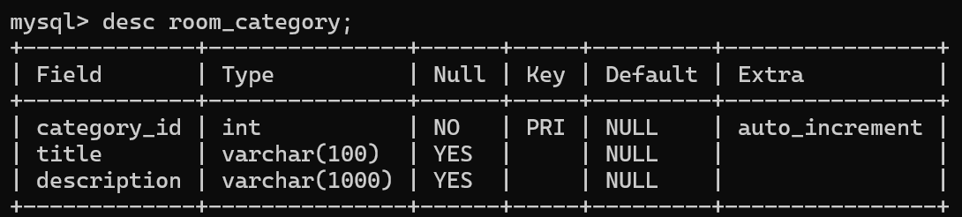**

**Room-Facility**

**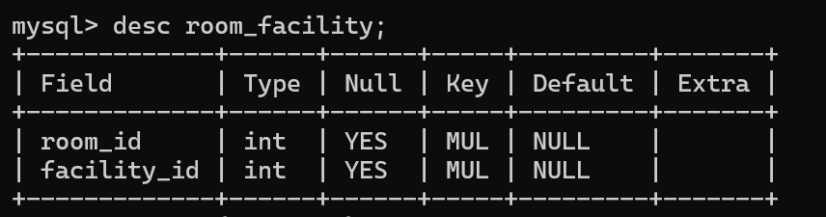**

**Rooms**

**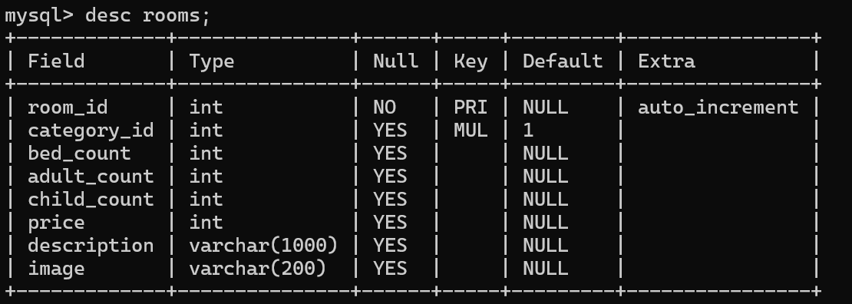**

**Users**

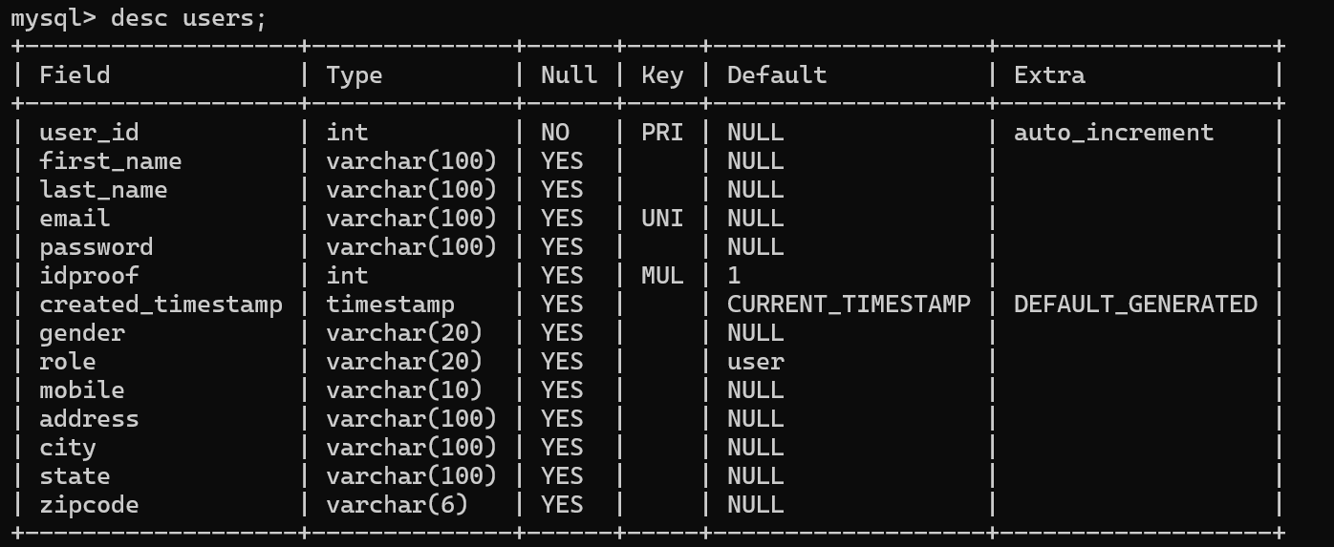

HomePage:

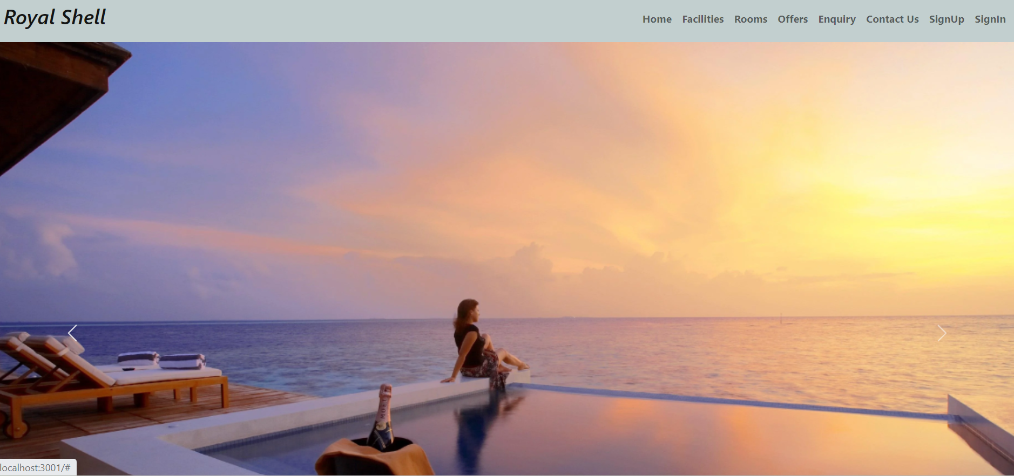

Signup page:

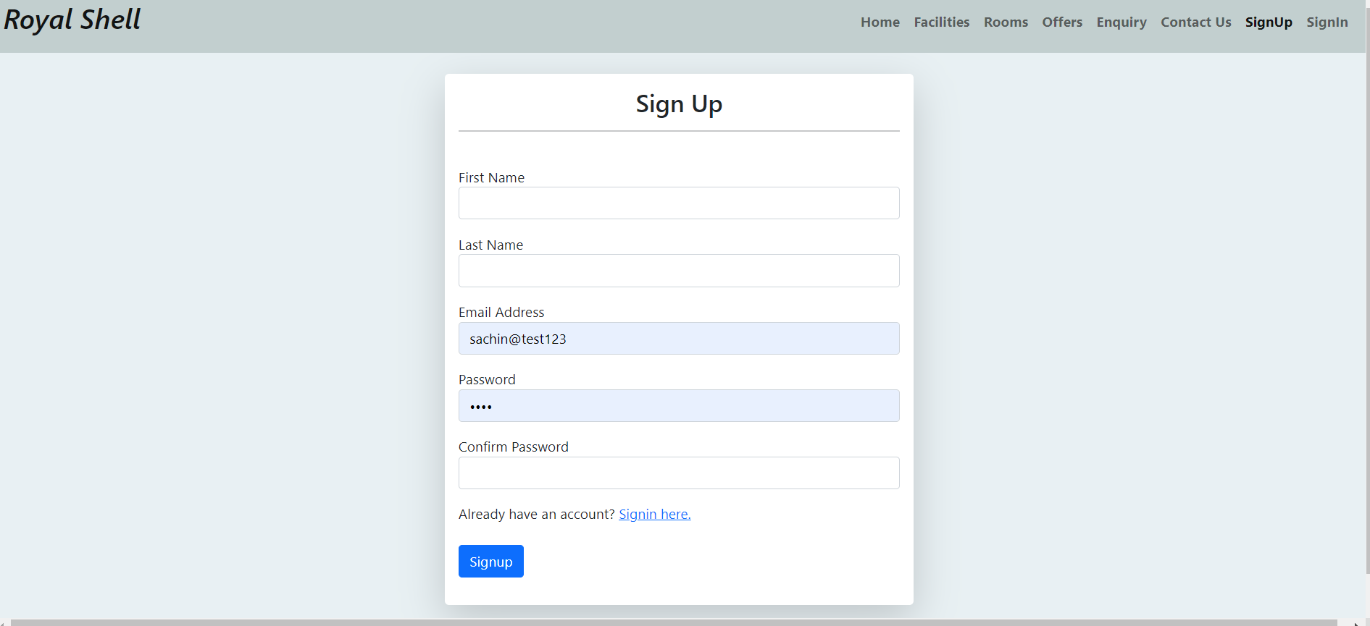

Sign in:

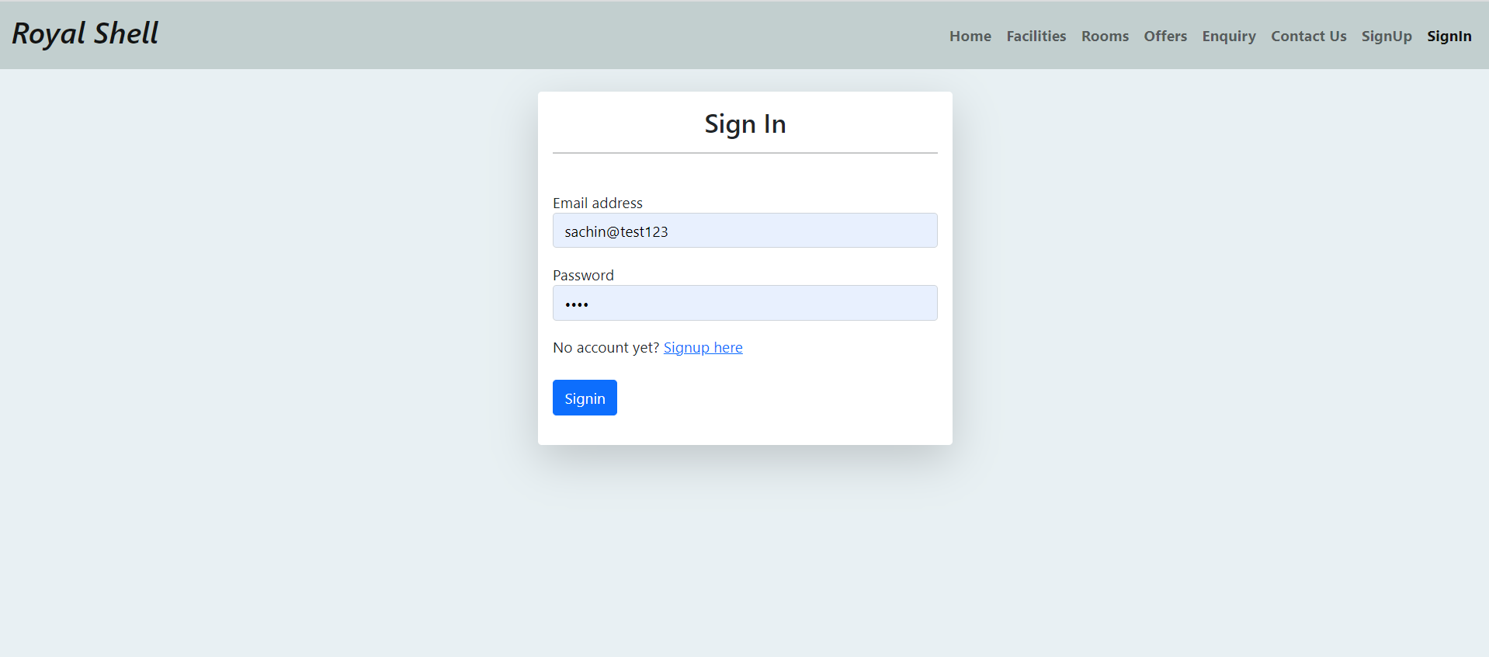

Book Room:

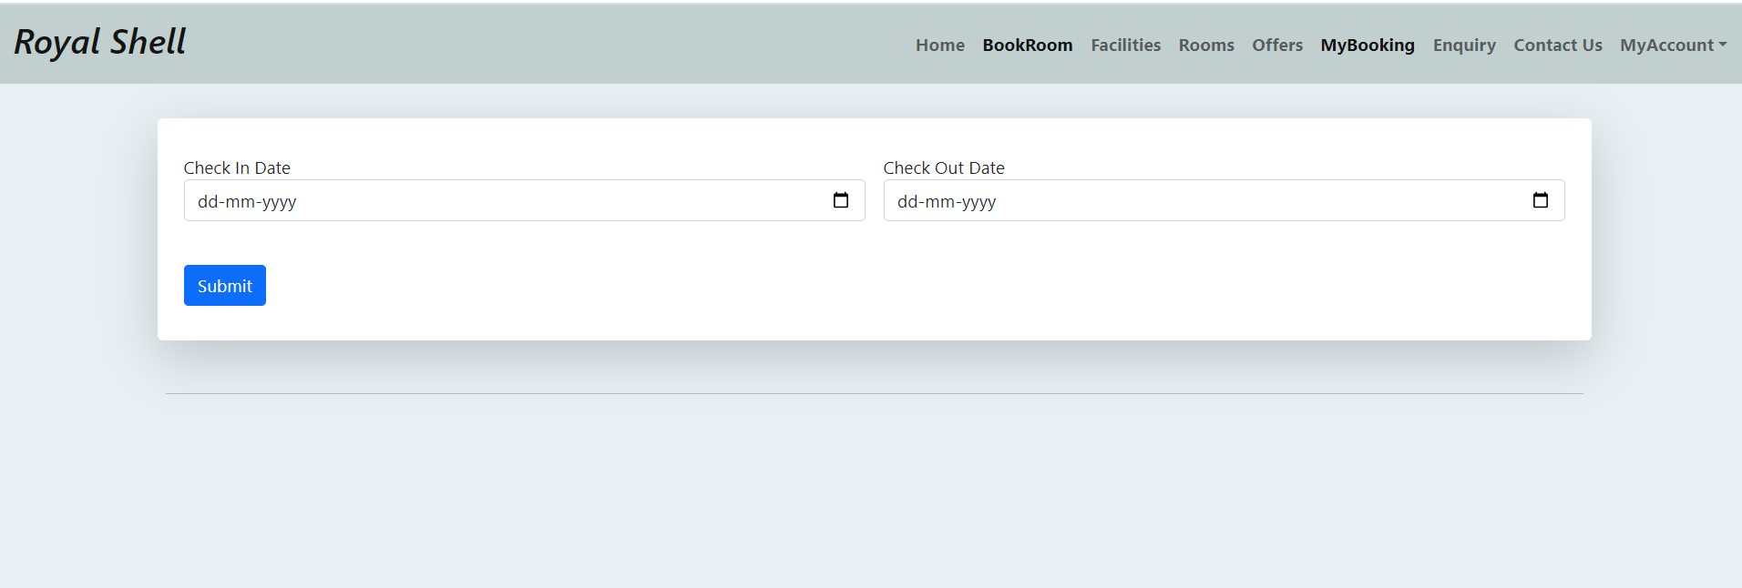

Facilities:



Offers:

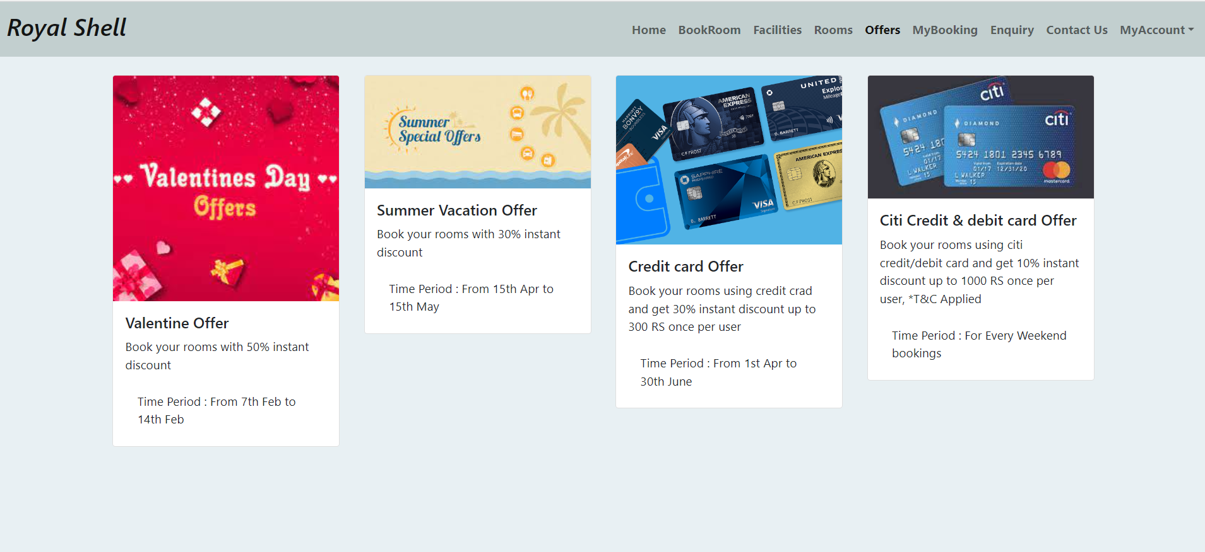

Enquiry:

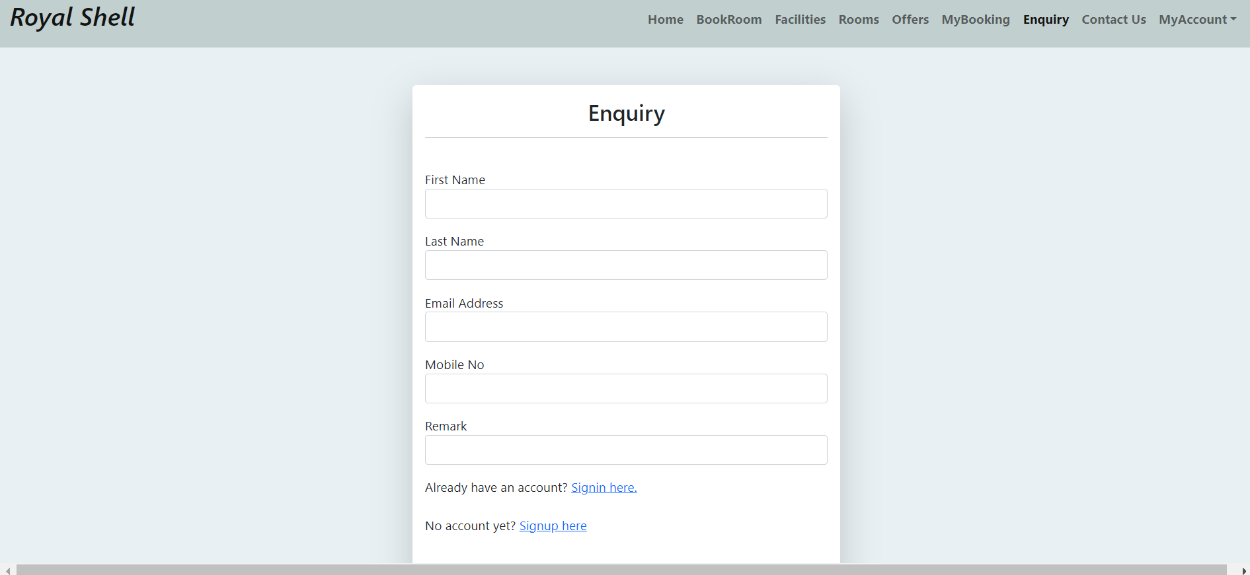

Admin Home:

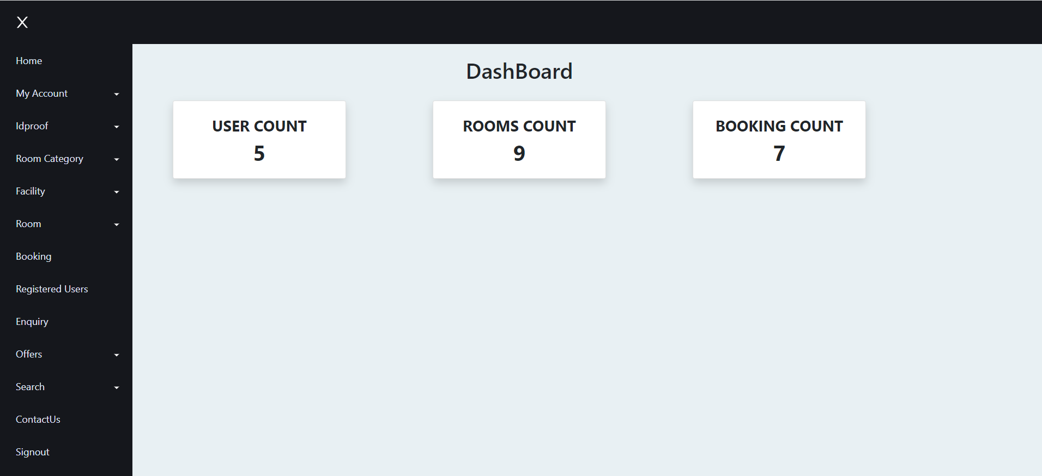

Admin- Account Update:

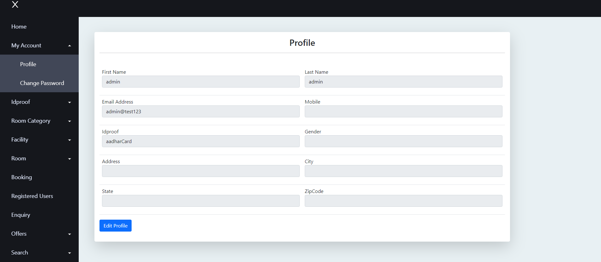

Admin- ID proof update:

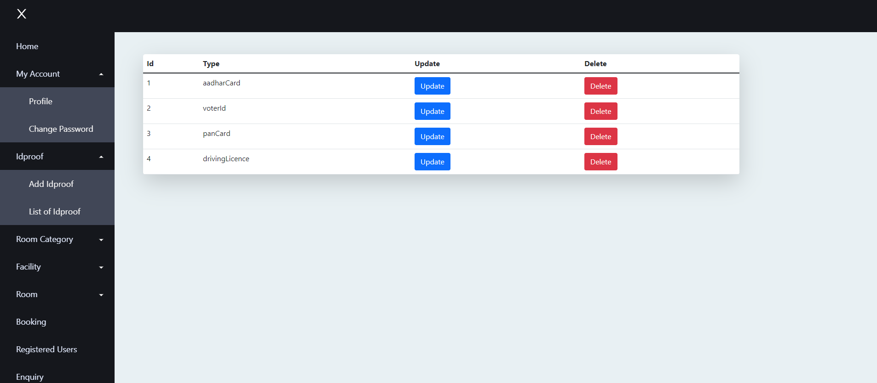

Admin-Room Update

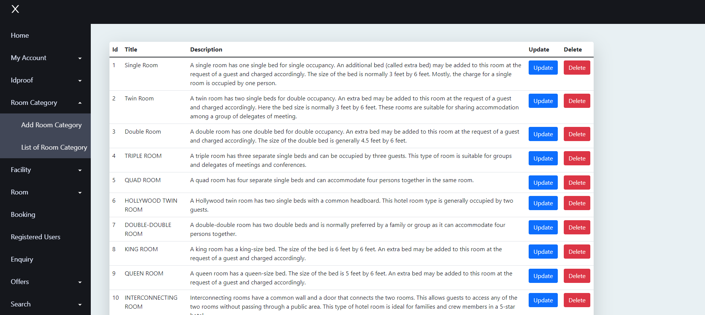

Admin-Facilities Update

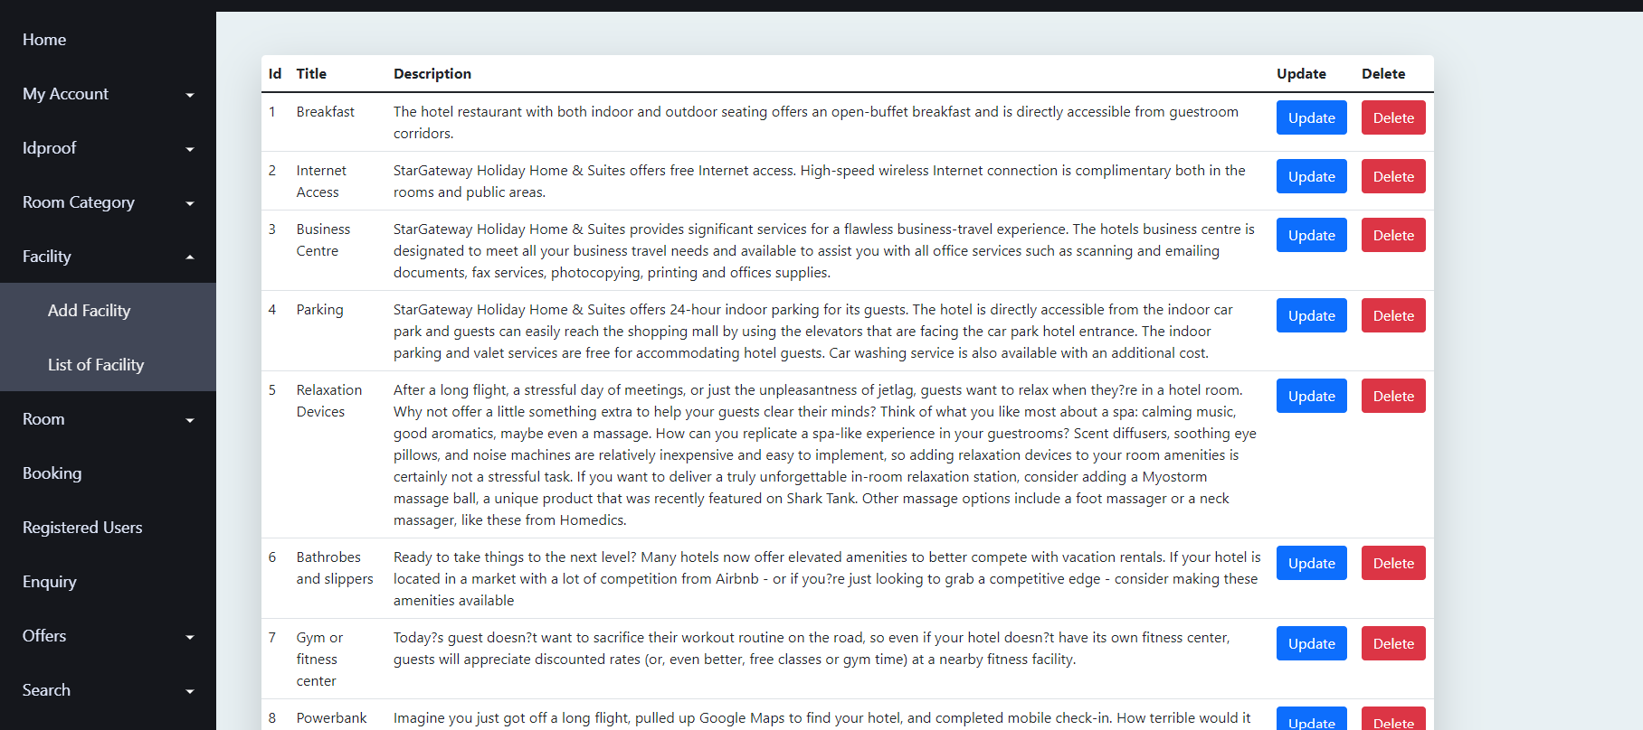

Admin: Room Update

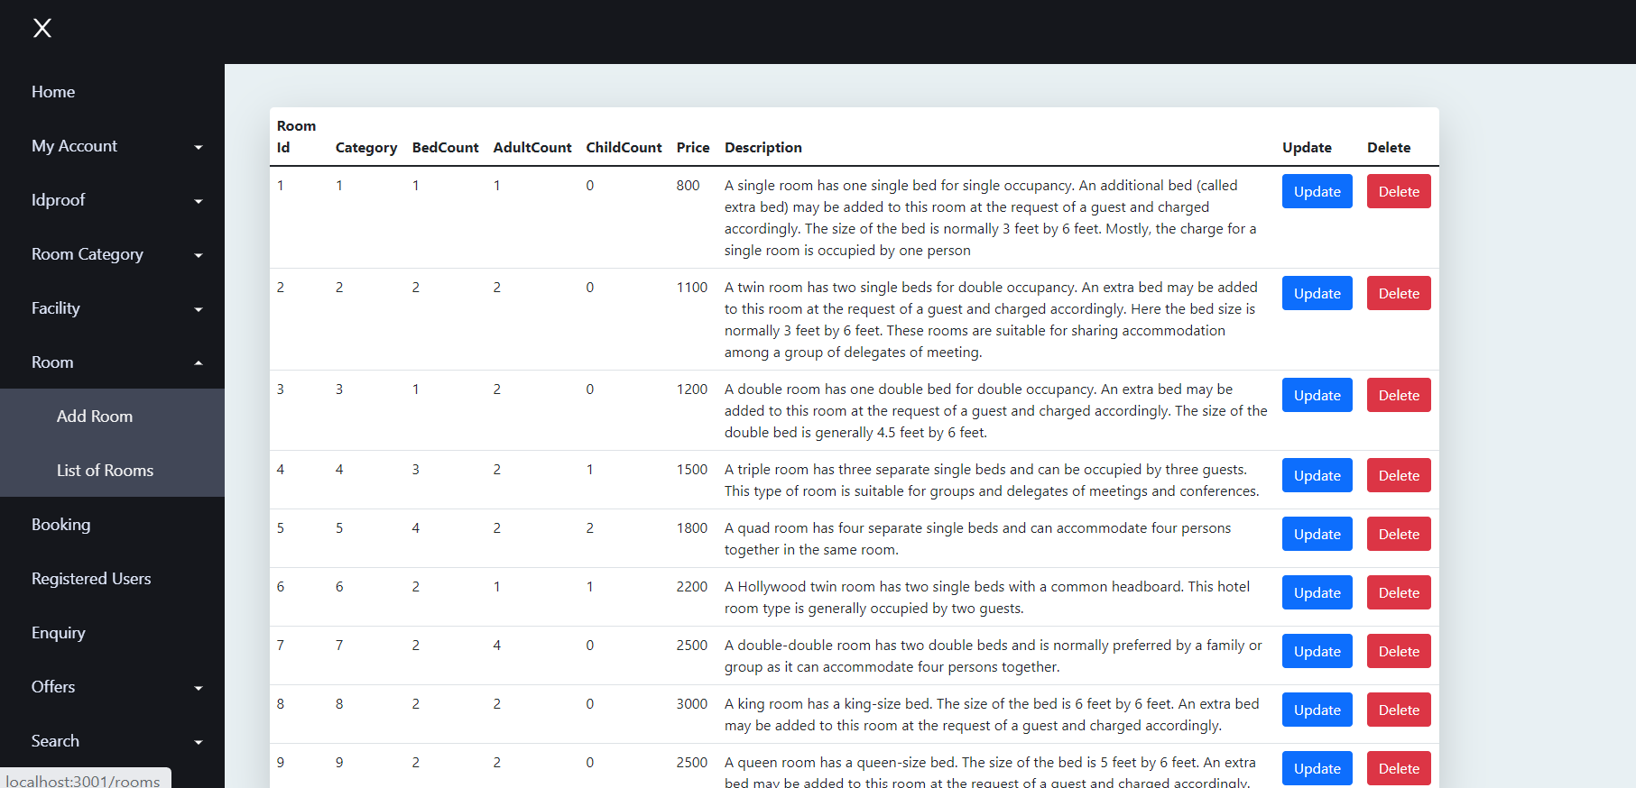

Admin-Register User

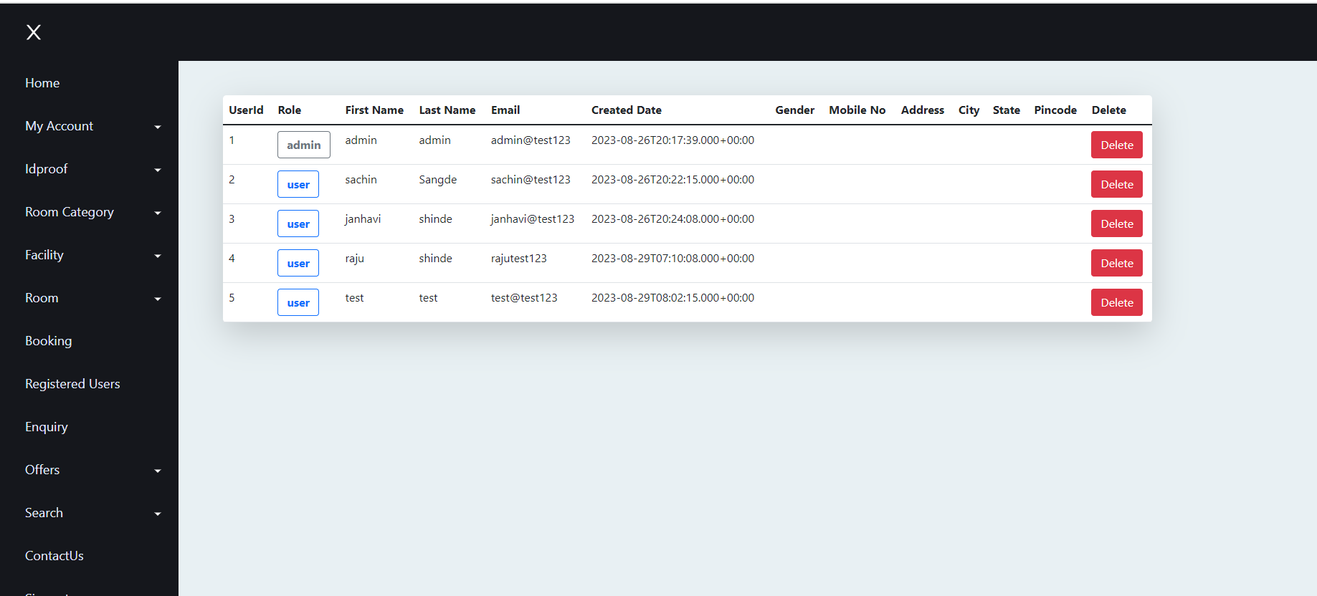

Admin – Update Offers

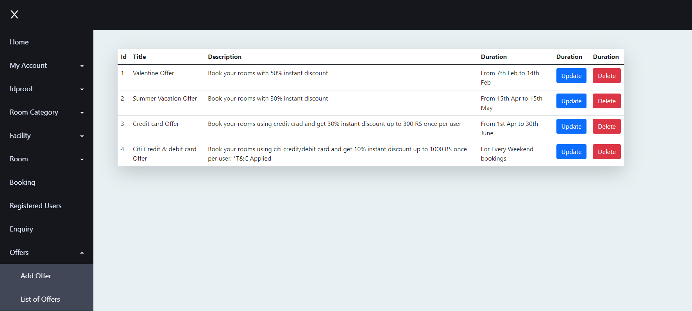

Admin-Update ContactUs

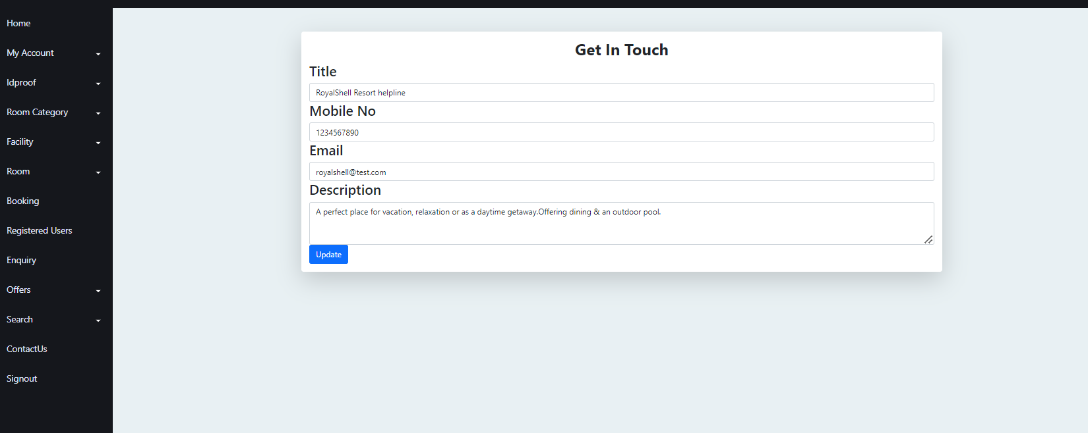

Admin –Search By ID

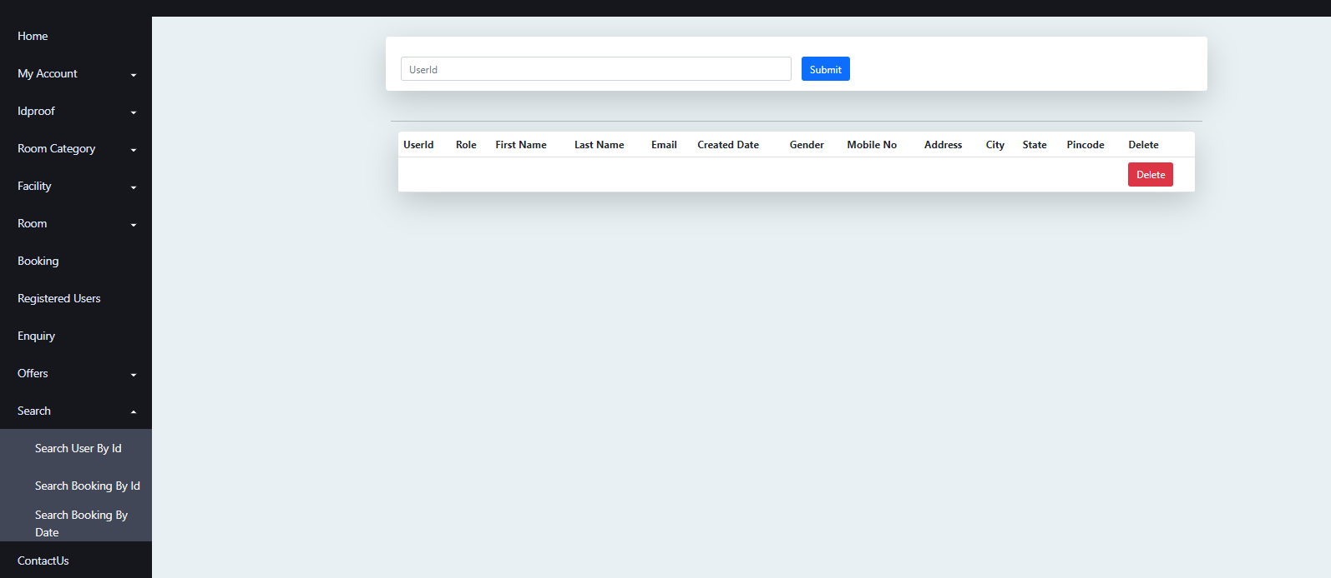

Admin –Search By Date

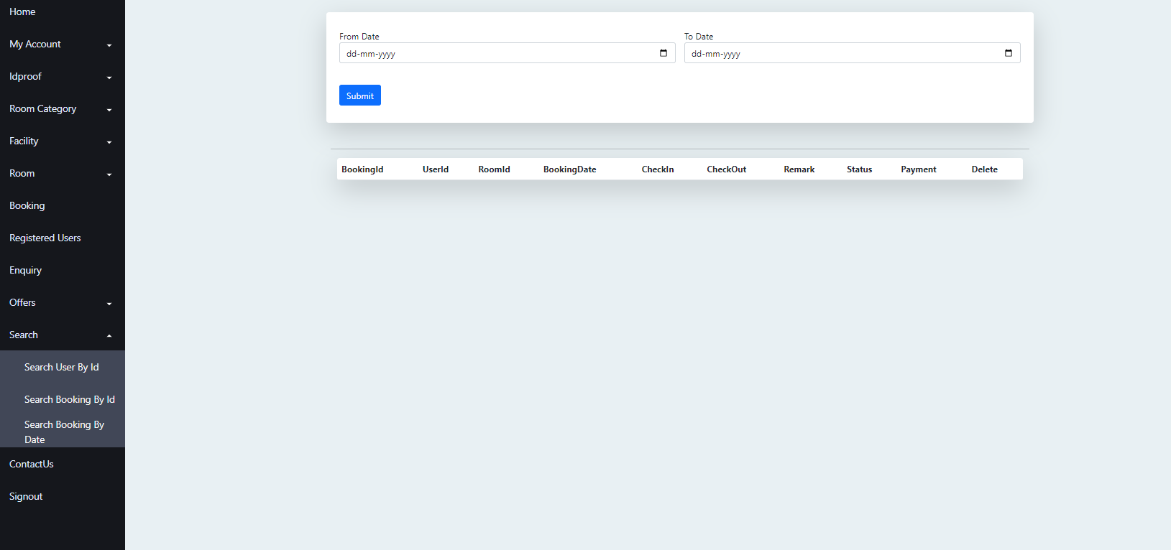

# Admin –change password

# 

# Social madia follow:

# 

# 

# 

# CONCLUSION

In conclusion, the online resort management project has successfully transformed traditional resort operations into a streamlined and efficient digital platform. Through its user-friendly interface, guests can seamlessly make reservations, access real-time information about amenities, and interact with resort staff. The project has significantly enhanced guest satisfaction by reducing waiting times and enhancing communication. The integrated payment system ensures secure and convenient transactions. The automated inventory management optimizes resource allocation and reduces wastage. Moreover, the project offers valuable insights through data analytics, enabling informed decision-making for future enhancements. Overall, the online resort management project demonstrates the immense potential of technology in revolutionizing the hospitality industry, making guest experiences more enjoyable and resort operations more effect.

## ONLINE REFERENCE

* 1. [www.Google.com](http://www.google.com/)
  2. [www.w3school.com](http://www.w3school.com/)
  3. [www.javatpoint.com](http://www.javatpoint.com/)
  4. [www.stackoverflow.com](http://www.stackoverflow.com/)
  5. [www.reactbootstrap.com](http://www.reactbootstrap.com/)
* **GIT LINK**

https://gitlab.com/cdac\_g24